SOFTWARE ENGINEERING & WEB DEVELOPMENT LAB MANUAL
PROJECT CASE STUDY: LEDGERLY — INVOICE & QUOTATION GENERATOR PWA

Experiment No. 6: Prepare DFD – Data Flow Diagram for the Project Topic

1. Pre-Requisites
• Understanding of structured systems analysis and Gane-Sarson / Yourdon DFD notations.
• Knowledge of DFD elements: External Entities, Processes, Data Stores, and Data Flows.
• Mastery of decomposition levels: Level 0 (Context Diagram), Level 1 (Subsystems), Level 2 (Low-Level Logic).

2. Objective
To construct and analyze Level 0, Level 1, and Level 2 Data Flow Diagrams for Ledgerly, detailing data transformations from initial user input through invoice compilation, calculation, payment ledgering, and document export.

3. Identification of DFD Elements
• External Entities: User / Business Owner, Client / Customer, External Services (QR API, Mail Client).
• Data Stores: D1: User Accounts (ig_users), D2: Session (ig_session), D3: Invoices (ig_invoices), D4: Customers (ig_customers), D5: Enterprises (ig_enterprises).
• Major Processes: 1.0 Auth & Session, 2.0 Customer Management, 3.0 Invoice Compilation, 4.0 Calculation & Tax Engine, 5.0 Payment Ledger, 6.0 Document Export.

4. DFD Level 0: Context Diagram
The Level 0 Context Diagram depicts Ledgerly as a central unified process interacting with external entities.

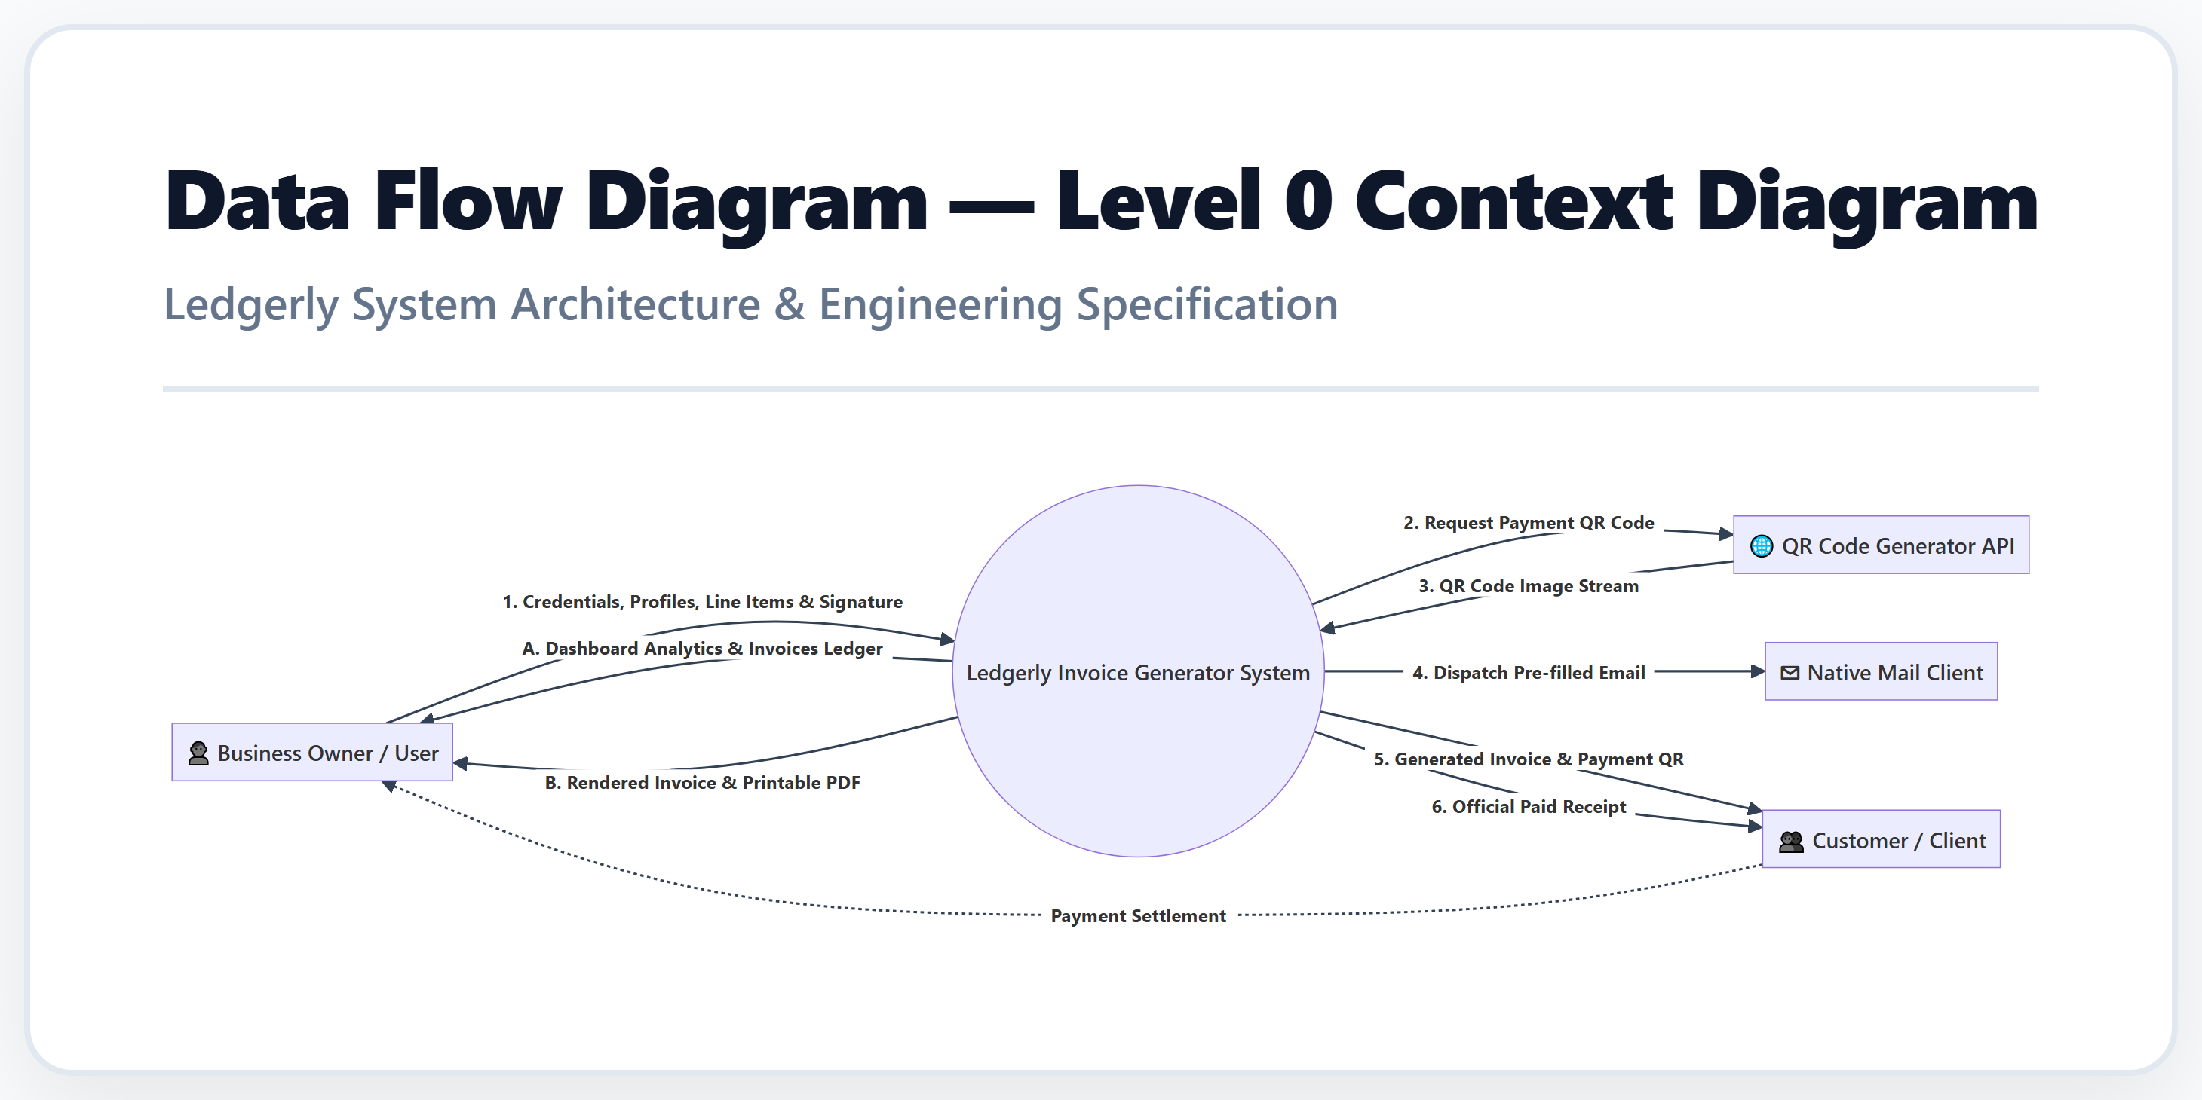
Figure: DFD Level 0: Context Diagram for Ledgerly

5. DFD Level 1: Functional Decomposition
The Level 1 DFD decomposes the system into discrete, cohesive processes showing interactions with localStorage data stores.

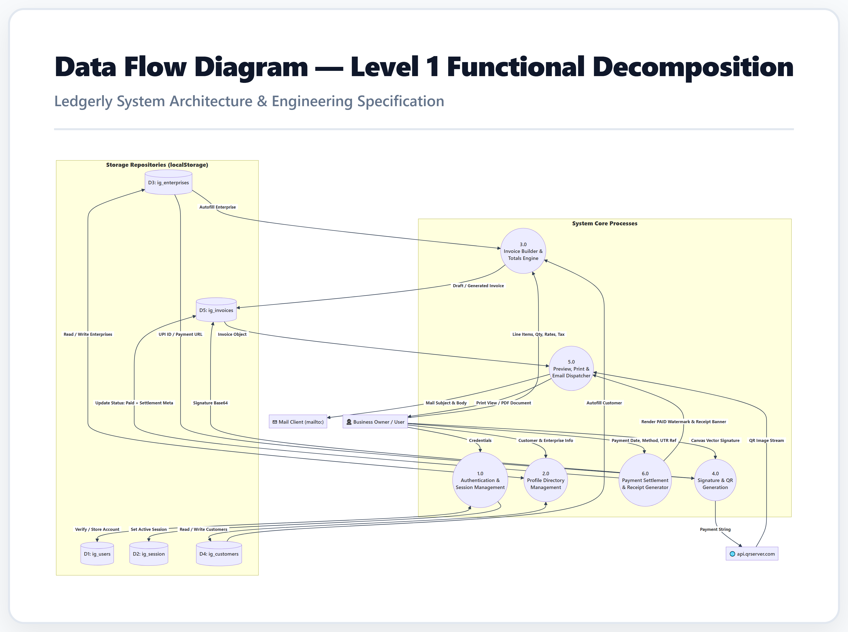
Figure: DFD Level 1: Subsystem Functional Decomposition

6. DFD Level 2: Invoice & Payment Settlement Pipeline
The Level 2 DFD provides low-level process logic for line item calculation, GST application, and installment ledger recording.

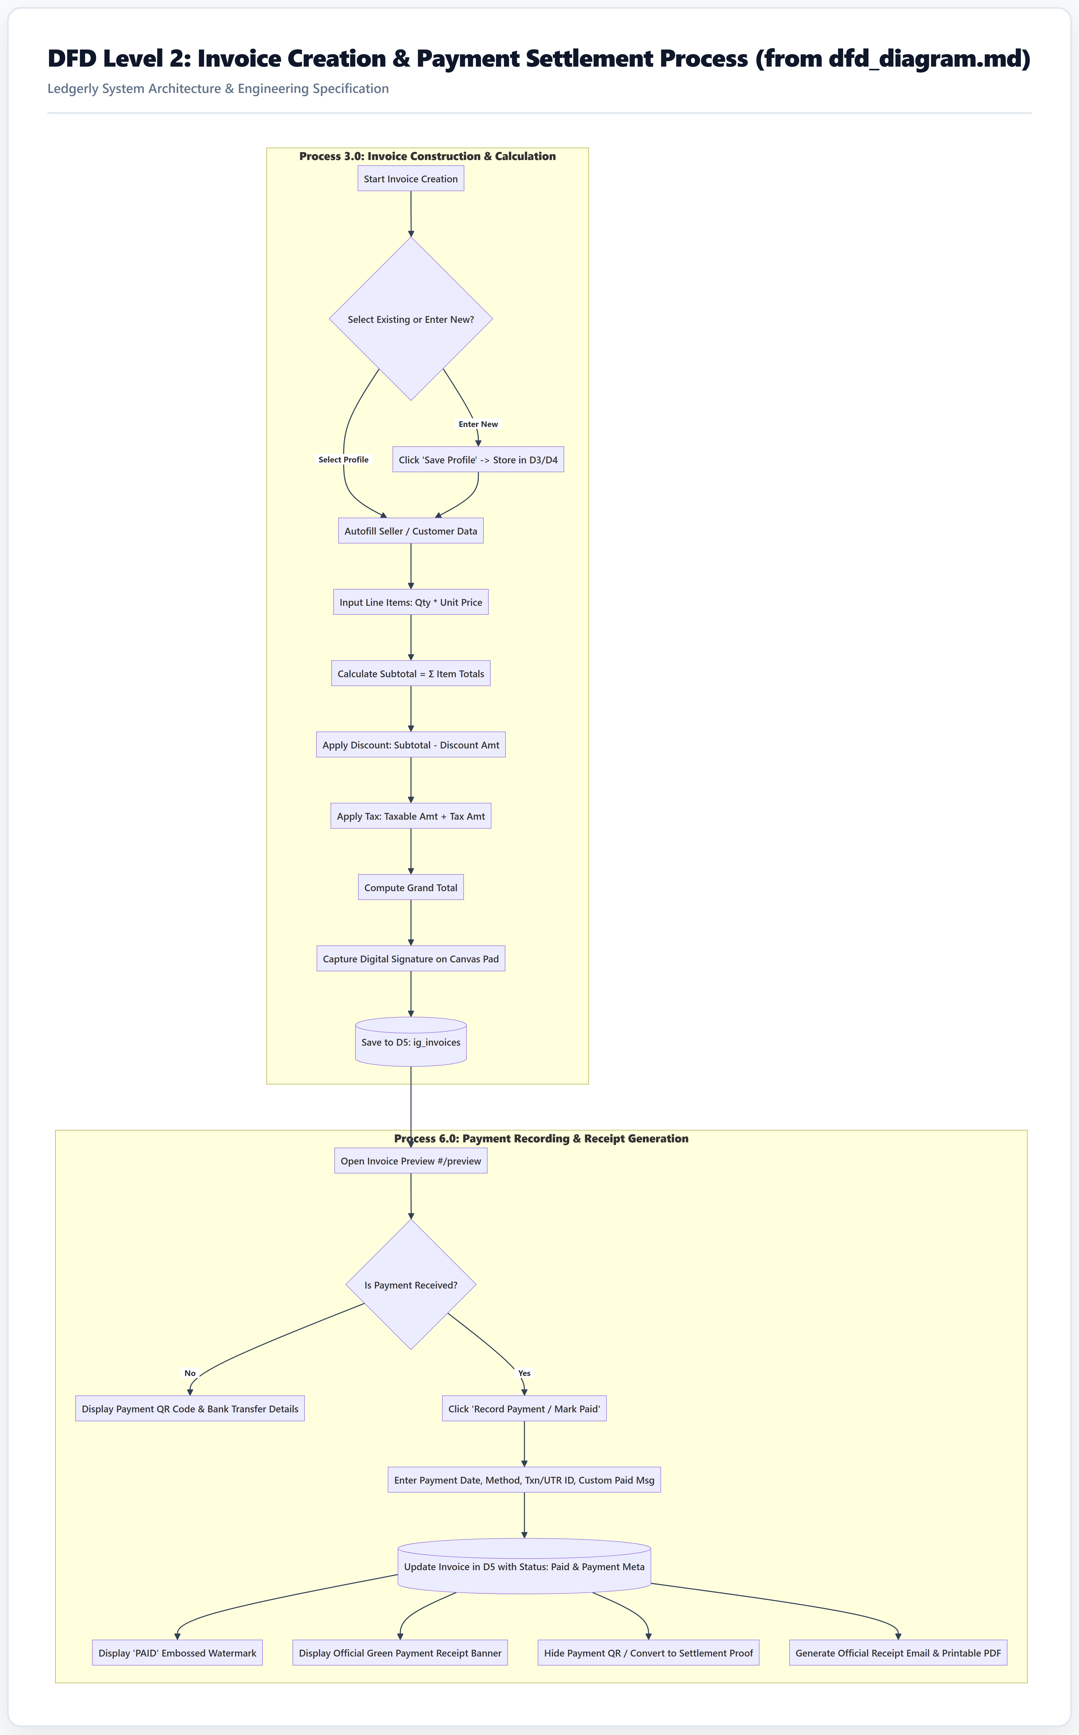
Figure: DFD Level 2: Invoice Calculation and Payment Pipeline

7. Expected Result & Conclusion
The multi-level Data Flow Diagrams clearly demonstrate how billing information flows, transforms, and persists throughout Ledgerly. This validates the system's modular architecture and adherence to high cohesion and low coupling.

